Fiber Optics Adapter for Camera LinkTM

PHIRETM

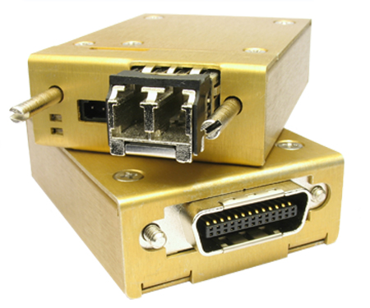



User Manual V1
^{PHIRE Series}



TABLE OF CONTENTS

1. Introduction 3
2. Packing List 3
3. Installation 4
4. Functionality 5
4.1 DC Power Input Port 5
4.2 Camera Link Port 5
4.3 LED Status Indicators 6
4.4 Optical I/O Port 6
4.5 Optical Fiber Cable 7
5. Trouble Shooting: 7
6. Product Safety and Regulatory Compliance: 8
6.1 Product Safety: 8
6.2 Regulatory Compliance: 8
7. Contact Us: 9

FIGURES

Figure 1 PHIRETM System Diagram 5
Figure 2 Electrical Connection of DC Input Connector (Front View) 5

TABLES

Table 1 Installation and Power up Steps for the PHIRE System 4
Table 2 LED Functionality Descriptions 6
Table 3 Trouble Shooting Procedures 8

1. Introduction
Camera LinkTM is a high-speed camera/frame grabber interface designed for high performance vision applications. However, normal copper links can only deliver the signal for 10 meters or shorter. PHIRE is designed to directly plug into the cameras/framgrabbers to covert the electrical signals into optical signals, which can be transported by optical fibers for over 80km without any kind of repeaters or amplifiers in between.

Key features of the PHIRE™ system:
- Fully supports Camera LinkTM base configuration
- Zero loss and transparent transport – no changes required for camera and/or frame grabber
- Supports up to 24 bits (3 taps) image data at max. of 85MHz
- LC duplex fiber interface
- Two LED indicators for system status
- Snap lock power connector with audible click when fully mated
- Single 5V~24V DC power supply on both ends
- Included international AC/DC adapters accept 100~240V AC power
- 0~60C operating temperature
- Maximum 2.4 W power consumption
- Six standard models for different applications (customized options available)

Model | PHR-60-M025 | PHR-68-M025 | PHR-85-M020 | PHR-60-S10 | PHR-68-S10 | PHR-85-S07
Image Data | 12 bits | 24 bits | 24 bits | 12 bits | 24 bits | 24 bits
CL CLK | 60 MHz | 68 MHz | 85 MHz | 60 MHz | 68 MHz | 85 MHz
Link Distance | 250 m* | 250 m* | 200 m* | 10 km** | 10 km** | 7 km**
*Distances are estimated with 50/125 μm multi-mode fiber.
** Distances are estimated with 9/125 μm single-mode fiber.

2. Packing List
Each standard package of the PHIRE system comes with the following items:

Items/Description | Quantity Included
PHIRE-CM module | 1
PHIRE-FG module | 1
International wall mount AC/DC power adapter (12V DC out) with Hirose RP34L plug | 2

3. Installation
Users would need the following items for proper installation.
1. | Camera Link compatible camera | X 1
2. | Camera Link compatible frame grabber | X 1
3. | Correct type of optical fiber cable (single mode or multi-mode, corresponding to the purchased PHIRE models) with LC connectors at both ends | X 1
4. | PHIRE-CM module | X 1
5. | PHIRE-FG module | X 1
6. | 5 ~ 24V DC power supply with correct connector plugs (two AC/DC adapters are included in the package) | X 2

To ensure safe and successful installation of the PHIRE™ system into your application, we STRONGLY RECOMMEND that you power off all related electronic devices, including the camera, frame grabber and PHIRE-CM/PHIRE-FG modules, before performing the following installation. Otherwise, system malfunction may happen and DAMAGE may be caused to the PHIRE™ system and/or your own system.

STEP | INSTALLATION STEPS
1 | Power off camera and frame grabber
2 | Plug PHIRE-CM module to the camera and secure the module with thumb screws
3 | Plug PHIRE-FG module to the frame grabber and secure the module with thumb screws
4 | Take off the caps on LC connectors at both ends of optical fiber cable.  Take off the caps on the LC fiber ports of PHIRE-CM and PHIRE-FG.  Plug LC fiber cable to both PHIRE-CM and PHIRE-FG. Users should hear a click sound, which indicates a successful mate.
5 | Connect power plugs to PHIRE-CM and PHIRE-FG. Users should hear a click sound, which indicates a successful mate.
STEP | POWER UP STEPS
6 | Power up Camera
7 | Power up the equipment (e.g., PC) where the frame grabber is installed
8 | Power up PHIRE-FG by plugging AC/DC adapter into the AC power source
9 | Power up PHIRE-CM by plugging AC/DC adapter into the AC power source
Table 1 Installation and Power up Steps for the PHIRE System

4. Functionality
The PHIRE™ system consists of two adapter modules, PHIRE-CM on the camera side and PHIRE-FG on the frame grabber (or PC) side. The block diagram of the PHIRE system is shown in Figure 1. All electrical signals on the left-hand side of PHIRE-CM have a one-to-one correspondence with the ones on the right-hand side of PHIRE-FG. Each adapter module converts its input electrical signals into a single optical signal and sends it to the other adapter module. It also receives a single optical signal from the other adapter module and converts it back into multiple output electrical signals. With the PHIRE™ system, the signal transmission distance between the camera and the frame grabber can be extended up to 80 kilometers without any repeaters or amplifiers in between. Most importantly, the PHIRE™ system is totally transparent to the camera and the frame grabber, which means seamless and easy system integration. The functionality of the PHIRE system is described in details below.

Camera Link
FVAL/LVAL/DVAL/SP
IMAGE DATA (24b)
PIXEL CLOCK
CC1 – CC4
SERIAL PORT
Fiber optics I/F
Camera Link
FVAL/LVAL/DVAL/SP
IMAGE DATA (24b)
PIXEL CLOCK
CC1 – CC4
SERIAL PORT
Fiber optics I/F
PHIRE-CM
PHIRE-FG

Figure 1 PHIRETM System Diagram

4.1 DC Power Input Port
Both PHIRE extender modules require external DC power input within the range of 5V~24V. The power consumption of each module is typically 3.6W. A 3-pin snap-lock male connector is mounted on the front panel of each module. Two AC/DC adapters each with a corresponding 3-pin female plug are included in the standard package. Figure 3 shows electrical connection of the mounted male connector.
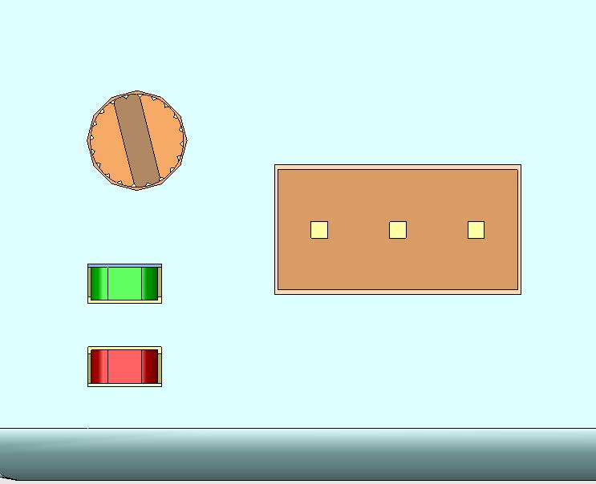
VIN+
VIN−
Reserved (DO NOT connect to external circuit)
1
2
3

Figure 2 Electrical Connection of DC Input Connector (Front View)

4.2 Camera Link Port
Each of the PHIRE modules has a MDR26 male plug for directly connecting to a 3M MDR26 female connector as specified in the Camera Link interface standard. The Camera Link interface of the PHIRE system is fully compatible with the Base configuration specified in the Camera Link standard, which consists of up to 24 bits of image data, FVAL, LVAL, DVAL, SP, CC1, CC2, CC3, CC4 and a bi-directional serial port (Figure 1). The exact bit assignment is defined in Appendix C of the Camera Link standard. There are six models available for the PHIRE systems, PHR-60, PHR-68 and PHR85, with multimode or single mode fiber options. PHR-60 supports max. 12 bits of image data with up to 60MHz of pixel clock rate. PHR-68 supports max. 24 bits of image data with up to 68MHz of pixel clock rate. PHR-85 supports up to 24 bits of image data with up to 85MHz pixel clock rate. For detail pin assignment, please refer to the Camera Link standard.

4.3 LED Status Indicators
The two LEDs on the front panel of each PHIRE adapter module indicate four operating status that are described in Table 2 below.

ITEM | LED COLOR | OPERATING STATUS
PWR/SYNC | Green | “Steady On” = power is on and module is operating normally
PWR/SYNC | Green | “Blinking” = module fails to lock camera pixel clock
CFG/LOS | Red | “Steady On” = module fails on initialization
CFG/LOS | Red | “Blinking” = loss of optical link
Table 2 LED Functionality Descriptions

4.4 Optical I/O Port
The optical I/O port employs standard industrial small form factor pluggable optical transceivers, which accept LC duplex connectors. The letter “M” in the PHIRE part number indicates the system comes with a SFP for multimode(MM) fiber applications while “S” comes with a SFP for single mode(SM) fiber applications. Please make sure you have the correct fiber cable before testing the units. For more information about the fiber cable, please see paragraph 4.5 of this manual.

The PHIRE system you have purchased is designed to accept both multimode and single mode SFP transceivers. This unique feature provides users with more flexibility and a cost effective solution to apply the same PHIRE system to different applications that require different link distance simply by changing the optical transceivers. If you would like to purchase additional SFP transceivers from Phrontier Technologies, please consult our technical support for assistance with selecting the correct SFP for your applications.

Inside the SFP, the optical transmitter housed in the left LC connector port (when user is facing the PHIRE unit) converts high speed electrical signals into optical signals which are transmitted by infrared laser over optical fiber. The optical receiver is located inside the right LC connector port and is responsible for converting optical signals into electrical signals. Since the active area of the optical port is smaller than the intersection of a human hair, any dust, soil or fiber debris can contaminate the optical I/O port and degrade system performance. Please make sure the protection cap is always on when the fiber cable is not plugged in.

WARNING: The infrared laser beam from the optical output port is invisible to human eyes. Users MUST NOT look directly into the optical I/O port while the unit is connected to power. Failure to do so may cause PERMANENT eye injury.

4.5 Optical Fiber Cable
Optical fiber is used to carry optical signals between the PHIRE-CM and PHIRE-FG modules. The fiber cable is not included in the package. You may purchase from Phrontier Technologies or other vendors.

There are two types of fibers, single mode (SM) fiber and multimode (MM) fiber. SM fiber cable is normally color coded in yellow and MM fiber in orange. The SM fiber is normally specified as 9/125 μm, which indicates the diameter of the fiber core to be 9 μm and the fiber cladding to be 125 μm. Although the LC connectors are interchangeable between SM and MM fiber cables, PHR-M series (for MM applications) will not work with SM fibers due to the excess optical losses.

There are two types of standard MM fibers, 50/125 μm and 62.5/125 μm that differ in core diameter but cannot be distinguished by the color of the cable. Although these two types of MM fibers can both be used with PHR-M series, the type of fiber chosen will affect the maximum transmission distance. With 50/125 MM fibers, 250 m to 300 m of maximum distance is normally achievable. With 62.5/125 MM fibers, the distance would be reduced to 150 m to 200 m. Some high performance MM fibers, such as Corning Infinicor SX+, can allow longer transmission distance. Please consult our technical support for more information.

5. Trouble Shooting:
Although the PHIRETM products are designed to be plug-and-play and user friendly, users may encounter some abnormal system operations in practice. The table below lists some possible abnormal operations that can be easily corrected by users before sending the units back to our technical support for investigation.

 | LED INDICATORS |  |  |  | POSSIBLE CAUSES | CORRECTION PROCEDURES
 | PHIRE-CM |  | PHIRE-FG |  | POSSIBLE CAUSES | CORRECTION PROCEDURES
 | PWR/  SYNC | CFG/  LOS | PWR/  SYNC | CFG/  LOS | POSSIBLE CAUSES | CORRECTION PROCEDURES
1 | ON | ON | ON | - | a) Initialization failure | a) Reset the PHIRE-CM power
2 | ON | - | ON | ON | a) Initialization failure | a) Reset the PHIRE-FG power
3 | Blink | - | Blink | - | a) Camera is not on  b) PHIRE-CM module is not connected securely | a) Check camera power and make sure the camera is functioning correctly  b) Inspect/secure PHIRE-CM connection
4 | ON | - | Blink | - | a) Camera malfunction after PHIRE initialized  b) Insecure connection after PHIRE-CM initialized | a) Inspect/secure PHIRE-CM connection  b) Reset camera and PHIRE system
5 | - | - | Blink | Blink | a) PHIRE-CM no power | a) Check PHIRE-CM power connection  b) Reset PHIRE system
6 | ON | Blink | - | - | a) PHIRE-FG no power | a) Check PHIRE-FG power  b) Reset PHIRE system
7 | ON | Blink | ON | Blink | a) Fiber cable is not fully engaged  b) Fiber connector end facet is contaminated  c) Optical I/O port is obstructed by foreign objects  d) Fiber cable breakage | a) Inspect/secure fiber cable connection  b) Use cotton sticks with alcohol to clean the fiber connector ends  c) Make sure the unit is power off before inspecting the optical I/O port  d) If foreign objects are found in the ferrule, use tweezers to take out the object  e) Do not use cotton sticks to clean the optical I/O. This could leave fiber debris inside the ferrule and cause more problems  f) Use a known good fiber cable to test PHIRE system’s functionality.
8 | PHIRE system functions normally but no clear image |  |  |  | a) Bad quality of CL cable  b) Incompatible camera and frame grabber | a) Use a known good CL cable to connect camera and frame grabber without going through PHIRETM system  b) Test system compatibility before install PHIRE

Table 3 Trouble Shooting Procedures

6. Product Safety and Regulatory Compliance:

6.1 Product Safety:
The fiber optical adaptors are designed and categorized as a Class 1 Laser product. ALWAYS avoid viewing directly into the optical ports, as the laser will cause serious damage to eyes. It is also recommended to connect the fiber cables before power-on the PHIRE system.

6.2 Regulatory Compliance:
Our products have been tested and found to be compliant with the following standards:
- FCC, Part 15, Class A
- AZ/NZS 3548: 1998
- EN55022 for Electromagnetic Emission
- EN55024 for Electromagnetic Immunity
- EN60950 for Low Voltage

The AC/DC power adaptors provided and the optical transceivers are compliant with applicable CE directives and FCC standards by the original manufacturers.

7. Contact Us:
Thank you for purchasing the PHIRE™ product. We hope you enjoy all the benefits brought to you by the unique design and functionalities.

If you need any assistance, please contact your distributor. You may also contact us via:

Phone: 866-389-2829 (Toll free for US and Canada)
626-964-3799 (International)

Fax: 801-998-1855

Emails:
For sales: sales@phrontier-tech.com
For technical support: support@phrontier-tech.com
For all other inquiries: info@phrontier-tech.com

Mail: US Office
Phrontier Technologies
2211 Hacienda Blvd, Suite 108
Hacienda Heights, CA 91745

Phrontier™ and PHIRE™ are the trademarks of Phrontier Technologies, LLC. Camera Link™ is the registered trademark of PULNix. All rights reserved.

